*Heaven’s Light is Our Guide*

# Rajshahi University of Engineering & Technology

# Department of Electrical & Computer Engineering

**Lab Report**Experiment No: 03

|  |  |
| --- | --- |
| Course Code | 1202 |
| Course Title | Circuit & System – II Sessional |

|  |  |
| --- | --- |
| **Submitted By:** | **Submitted To:** |
| Name             : Sharmin Akter  Roll                : 2210055  Registration : 1109  Session           : 2022-23 | Oishi Jyoti,  Assistant Professor,  Electrical & Computer Engineering, RUET. |

**INDEX**

1. Experiment No
2. Experiment Name
3. Objectives
4. Required Apparatus
5. Theory
6. Circuit Diagram
7. Procedure
8. Data Table
9. Result
10. Discussion

**Experiment No:** 03

**Name of the Experiment:** Power measurement of a 3-phase balanced system using two Wattmeter method.

**Objectives:**

* To determine total power from the balanced 3-phase system.
* To analize three-phase systems.

**Required Apparatus:**

1. Source

2. Ammeter/Clamp meter

3. Resistor (Three)

4. Connecting Wire

5. Multimeter

6. VARIAC

7. Wattmeter

**Theory:** In a 3-phase balanced system, we can measure the total power using the Two Wattmeter Method. This method is simple and works for both star (Y) and delta (Δ) connected systems. A three-phase system has three electrical currents that are 120 degrees apart. In a balanced system, the load on each phase is the same.

To measure the power, we use two wattmeters. These wattmeters are connected to two of the three phases. The power shown by each wattmeter depends on the voltage, current, and the angle between them (the phase angle).

Here, $P_{T}={\sqrt{3} V}_{L}I_{L}$

**Circuit Diagram:**

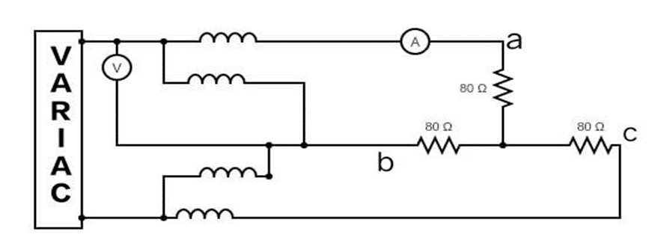

**Procedure:**

* A circuit was created following the circuit diagram using the components required.
* Voltmeter and ammeter were connected in the places marked in the diagram.
* Readings of the meters were recorded in a data table and error was calculated.

**Data Table:**

|  |  |  |  |  |  |  |  |
| --- | --- | --- | --- | --- | --- | --- | --- |
| **Sl** | $$P_{1}$$ | $$P_{2}$$ | $$P_{T(M)}$$ | $$P_{T(Cal)}$$ | $$I_{L}$$ | $$V_{L}$$ | **% error** |
| 1 | 22 | 28 | 50 | 66.554 | 0.53 | 72.5 | 24.87 |
| 2 | 28 | 32 | 60 | 84.28 | 0.609 | 79.9 | 28.8 |
| 3 | 36 | 40 | 76 | 100.8199 | 0.666 | 87.4 | 24.61 |
| 4 | 45 | 48 | 93 | 119.208 | 0.726 | 94.8 | 21.98 |
| 5 | 50 | 50 | 100 | 128.085 | 0.75 | 98.6 | 21.93 |

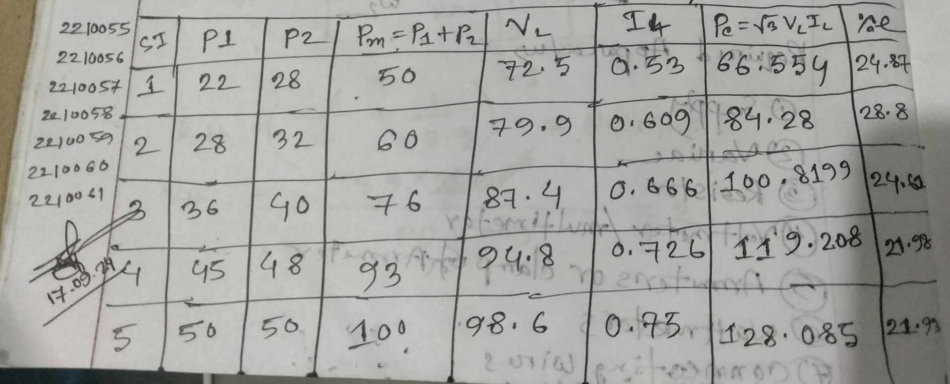

**Result:**

This experiment satisfied those two equaltions;

$$P_{T}={\sqrt{3} V}_{L}I_{L}$$

and the calculative power and the mathematical power is almost equal

but there is a little bit error .the average error is

% error = (24.87+28.8+24.61+21.98+21.93)/5 %

= 24.44%

**Discussion:**

Ignoring the small margin of error, the experiment proved the theory. Error could have been avoided but due to some external & internal factors it was unavoidable.